APARTMENT SELECTION PROBLEM
Sample: Helping new member in the city select the best apartment.
Objectives: To use AHP method to help new member in the city select an apartment that is best in terms of the various apartment’s criteria in town.
Criterion 1: Quality of life where the apartment is located.
Criterion 2: Nearness to place of work.
Criterion 3: Nearness to all weather roads and good network.
Criterion 4: Quality Security
Criterion 5: Cost of monthly rent.
The new member has been presented with four suggestions: Highrise,Avenue,and Green park and Mount View apartments.
Step 1: Developing the Hierarchy
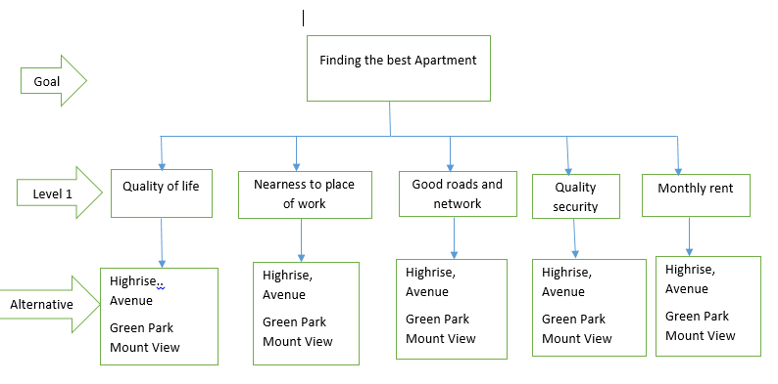
Figure 1: Apartment Selection Hierarchy

Step 2: Establishing Priorities between criteria
Cost of monthly rent is two times as important as Quality of life where the apartment is located.
Nearness to place of work is three times as important as nearness to all weather roads and good network.
Quality security is four times as important as cost of monthly rent.
Quality of life where the apartment is located is two times as important as nearness to all weather roads and good network.
Relative Importance | Value
Equal importance/quality | 1
Somewhat more important/better | 3
Definitely more important/better | 5
Much more important/better | 7
Very much more important/better | 9
The numbers 2, 4, 6, and 8 are half way positions between the values above.
Step Three: Conducting pairwise comparison and computing weight matrix.
By noting that: “The scale assumes that the ROW (first) criterion being ranked is of equal or greater importance than the COLUMN (second) criterion. If you have a pairing where the row criterion is less important than the column, use the reciprocal value (1/3, 1/5, 1/7, or 1/9).” Therefore the pairwise comparison will generate the following:
 | Quality of life | Nearness to place of work | Good roads and network | security | Rent
Quality of life | 1 | 3 | 2 | 1/3 | 1/2
Nearness to place of work | 1/3 | 1 | 3 | 1/2 | 5
Good roads and network | 1/2 | 1/3 | 1 | 1/2 | 2
Security | 3 | 2 | 2 | 1 | 4
Rent | 2 | 1/5 | 1/2 | 1/4 | 1
Converting it to decimal places for convenience
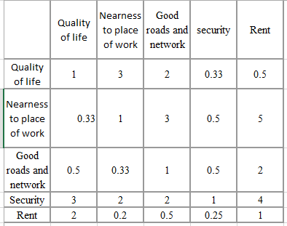
Computing the column sum for each column first
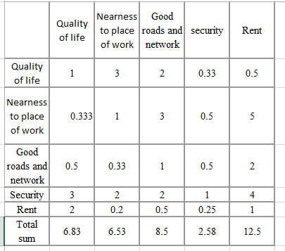

Dividing each entry by the total of its column
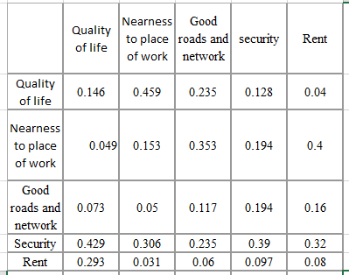
Calculating weight for each criteria by computing the average of each row in
 | weight | % 0f final decision | Product
Quality of life | 0.2016 | 20.16% | 1.852
Nearness to place of work | 0.2298 | 22.98% | 1.381
Good roads and network | 0.1188 | 11.88% | 0.688
Security | 0.336 | 33.6% | 2.087
Rent | 0.1122 | 11.22% | 0.705
Checking for Consistency
X 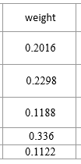 = 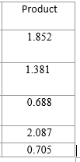
Finding theratio of each element to the corresponding weight in w and averaging these ratios. For example, this averaged ratio is:
$$\frac{\frac{1.852}{0.2016}+\frac{1.381}{0.2298}+\frac{0.688}{0.1188}+\frac{2.087}{0.336}+\frac{0.705}{0.1122}}{5}=5.43$$
Consistency Index (CI) as:
$$CI= \frac{\left(averaged ratio above\right)- n}{n-1}$$
$$CI= \frac{\left(5.43\right)- 5}{5-1}=0.1075$$
If the decision maker is completely consistent then:
- aij .ajk = aik (for all i,j,k),
- λ_{max} andλ_{average} = n where λ is an eigenvalue of the matrix A
- CI = 0.
Computing the Consistency Ration (CR) as
$$CR= \frac{CI}{RI}$$
Random Consistency Index Table.
n | 2 | 3 | 4 | 5 | 6 | 7 | 8 | 9 | 10
RI | 0 | 0.58 | 0.90 | 1.12 | 1.24 | 1.32 | 1.41 | 1.45 | 1.51
RI is therefor at 5 ( 5.43): = 1.12
CR = $\frac{0.1075}{1.12}$ = 0.081
0.081<0.1 hence the pairwise comparison is considered consistent for weight of criteria.

Step 4: Comparing the Alternatives
Crieterion 1: Quality of life where the apartment is located.
 | Highrise | Avenue | Green Park | Mount View
Highrise | 1 | 2 | 5 | 1
Avenue | 1/2 | 1 | 3 | 2
Green park | 1/5 | 1/3 | 1 | 1/4
Mount View | 1 | 1/2 | 4 | 1
computing the column sum for each column first
 | Highrise | Avenue | Green Park | Mount View
Highrise | 1 | 2 | 5 | 1
Avenue | 1/2 | 1 | 3 | 2
Green park | 1/5 | 1/3 | 1 | 1/4
Mount View | 1 | 1/2 | 4 | 1
sum | 2.7 | 3.83 | 13.00 | 4.25
Dividing each entry by the total of its column
 | Highrise | Avenue | Green Park | Mount View
Highrise | 0.37 | 0.52 | 0.38 | 0.24
Avenue | 0.19 | 0.26 | 0.23 | 0.47
Green park | 0.07 | 0.09 | 0.08 | 0.06
Mount View | 0.37 | 0.13 | 0.31 | 0.24
sum | 1 | 1 | 1 | 1

Priority vector
 | Highrise | Avenue | Green Park | Mount View | Weight | % | product
Highrise | 0.37 | 0.52 | 0.38 | 0.24 | 0.38 | 38% | 2.55
Avenue | 0.19 | 0.26 | 0.23 | 0.47 | 0.29 | 29% | 1.21
Green park | 0.07 | 0.09 | 0.08 | 0.06 | 0.07 | 7% | 0.751
MountView | 0.37 | 0.13 | 0.31 | 0.24 | 0.26 | 26% | 1.065
Checking for Consistency
CI =$$\frac{\frac{2.55}{0.38}+\frac{1.21}{0.29}+\frac{0.751}{0.07}+\frac{1.065}{0.26}}{4}=6.42$$
$$CI= \frac{\left(6.42\right)- 4}{4-1}=0.81$$
$CR= \frac{CI}{RI}=\frac{0.81}{1.24}$ = 0.65
0.65< 1 hence the pairwise comparison is considered consistent for weight of criteria.
Criterion 2: Nearness to place of work.
 | Highrise | Avenue | Green Park | Mount View
Highrise | 1 | 1/2 | 3 | 2
Avenue | 2 | 1 | 5 | 1
Green park | 1 | 1/2 | 1 | 4
Mount View | 1/5 | 1/3 | 1/4 | 1
sum | 4.2 | 2.33 | 9.25 | 8
Dividing each entry by the total of its column
 | Highrise | Avenue | Green Park | Mount View | Weight | % | product
Highrise | 0.23 | 0.21 | 0.32 | 0.25 | 0.25 | 25% | 1.406
Avenue | 0.47 | 0.43 | 0.54 | 0.125 | 0.39 | 39% | 2.253
Green park | 0.23 | 0.21 | 0.12 | 0.5 | 0.265 | 26.5% | 1.042
Mount View | 0.047 | 0.14 | 0.02 | 0.125 | 0.083 | 8.3% | 0.328

Checking for Consistency
CI =$$\frac{\frac{1.406}{0.25}+\frac{2.253}{0.39}+\frac{1.042}{0.265}+\frac{0.328}{0.083}}{4}=4.821$$
$$CI= \frac{\left(4.821\right)- 4}{4-1}=0.273$$
$CR= \frac{CI}{RI}=\frac{0.273}{1.12}$ = 0.242 < 1 hence the pairwise comparison is considered consistent for weight of criteria
Criterion 3: Nearness to all weather roads and good network.
 | Highrise | Avenue | Green Park | Mount View
Highrise | 1 | 2 | 5 | 1
Avenue | 1/2 | 1 | 3 | 2
Green park | 1/5 | 1/3 | 1 | 1/4
Mount View | 1 | 1/2 | 4 | 1
Dividing each entry by the total of its column
 | Highrise | Avenue | Green Park | Mount View | Weight | % | product
Highrise | 0.37 | 0.52 | 0.38 | 0.24 | 0.38 | 38% | 2.55
Avenue | 0.19 | 0.26 | 0.23 | 0.47 | 0.29 | 29% | 1.21
Green park | 0.07 | 0.09 | 0.08 | 0.06 | 0.07 | 7% | 0.751
MountView | 0.37 | 0.13 | 0.31 | 0.24 | 0.26 | 26% | 1.065
Checking for Consistency
CI =$$\frac{\frac{2.55}{0.38}+\frac{1.21}{0.29}+\frac{0.751}{0.07}+\frac{1.065}{0.26}}{4}=6.42$$
$$CI= \frac{\left(6.42\right)- 4}{4-1}=0.81$$
$CR= \frac{CI}{RI}=\frac{0.81}{1.24}$ = 0.65
0.65< 1 hence the pairwise comparison is considered consistent for weight of criteria

Criterion 4: Quality Security
 | Highrise | Avenue | Green Park | Mount View
Highrise | 1 | 2 | 1/2 | 4
Avenue | 1/2 | 1 | 3 | 1/5
Green park | 2 | 1/3 | 1 | 1/4
Mount View | 1/4 | 5 | 4 | 1
Sum | 3.625 | 8.33 | 8.5 | 5.45
Dividing each entry by the total of its column
 | Highrise | Avenue | Green Park | Mount View | Weight | % | product
Highrise | 0.276 | 0.24 | 0. | 0.06 | 0.73 | 73% | 1.535
Avenue | 0.137 | 0.12 | 0.23 | 0.35 | 0.03 | 3% | 0.555
Green park | 0.55 | 0.04 | 0.08 | 0.12 | 0.05 | 5% | 1.565
MountView | 0.069 | 0.6 | 0.31 | 0.47 | 0.18 | 18% | 4.5635

CI =$$\frac{\frac{1.535}{0.73}+\frac{0.555}{0.03}+\frac{1.565}{0.05}+\frac{4.5635}{0.18}}{4}=4.83$$
$$CI= \frac{\left(4.83\right)- 4}{4-1}=0.277$$
$CR= \frac{CI}{RI}=\frac{0.277}{1.12}$ = 0.24 < 1 1 hence the pairwise comparison is considered consistent for weight of criteria
Criterion 5: Cost of monthly rent.
 | Highrise | Avenue | Green Park | Mount View
Highrise | 1 | 1/2 | 3 | 2
Avenue | 2 | 1 | 5 | 1
Green park | 1 | 1/2 | 1 | 4
Mount View | 1/5 | 1/3 | 1/4 | 1
sum | 4.2 | 2.33 | 9.25 | 8

Dividing each entry by the total of its column
 | Highrise | Avenue | Green Park | Mount View | Weight | % | product
Highrise | 0.23 | 0.21 | 0.32 | 0.25 | 0.25 | 25% | 1.406
Avenue | 0.47 | 0.43 | 0.54 | 0.125 | 0.39 | 39% | 2.253
Green park | 0.23 | 0.21 | 0.12 | 0.5 | 0.265 | 26.5% | 1.042
Mount View | 0.047 | 0.14 | 0.02 | 0.125 | 0.083 | 8.3% | 0.328
Checking for Consistency
CI =$$\frac{\frac{1.406}{0.25}+\frac{2.253}{0.39}+\frac{1.042}{0.265}+\frac{0.328}{0.083}}{4}=4.821$$
$$CI= \frac{\left(4.821\right)- 4}{4-1}=0.273$$
$CR= \frac{CI}{RI}=\frac{0.273}{1.12}$ = 0.242 < 1 hence the pairwise comparison is considered consistent for weight of criteria

Step 5: Conclusion
 | Quality of life | Nearness to place of work | Good roads and network | security | Rent | sum | Average
Highrise | 0.38 | 0.25 | 0.38 | 0.73 | 0.25 | 1.99 | 0.398
avenue | 0.29 | 0.39 | 0.29 | 0.03 | 0.39 | 1.39 | 0.278
Green park | 0.07 | 0.265 | 0.07 | 0.05 | 0.265 | 0.72 | 0.144
Mount view | 0.26 | 0.083 | 0.26 | 0.18 | 0.083 | 0.866 | 0.173
Hence Highrise apartments have the highest ratio

Overall consistency of the hierarchy in our example above is given by
$$\overline{CR}=\frac{\sum_{i}{w_{i}{CI}_{i}}}{\sum_{i}{w_{i}{RI}_{i}}}$$
$\overline{CR}=\frac{\sum_{i}{w_{i}{CI}_{i}}}{\sum_{i}{w_{i}{RI}_{i}}}$ = $=\frac{\left(0.81\right)\left(0.398\right)+\left(0.227\right)\left(0.278\right)+0.81\left(0.144\right)+\left(0.81\right)\left(0.398\right)+\left(0.227\right)\left(0.278\right)+0.81\left(0.144\right)}{\left(1.24\right)\left(0.398\right)+\left(1.12\right)\left(0.278\right)+\left(0.24\right)\left(0.144\right)+\left(0.81\right)\left(0.398\right)+\left(0.227\right)\left(0.278\right)+0.81\left(0.144\right)}$ = 0.0234
= 2.34%
Therefor APH method helps make a Complete, Redundant, Operational, Mutual Independent decisions. The best apartment that the new guy in the city is supposed to rent is Highrise since it has the highest weight ratio in terms of quality of life, nearness to place of work, nearness to all weather roads and network, quality security and cost of monthly rent.

